IPC144 -Assignment 1

Zian Choudhury – Section NVV – ID#131048209

# Section 1.1 - Output

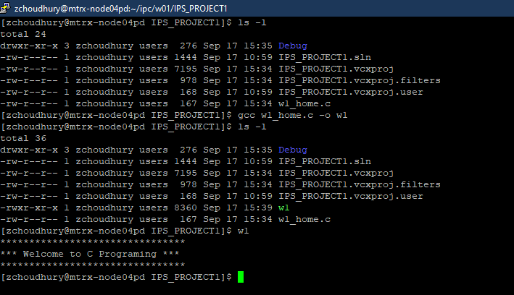

# Section 1.2 - Reflection

In completing the assignment, several different aspects of basic C programming were introduced such as inclusion of libraries, the main function and general syntax. The printf command had been introduced and in the at home assignment taught the use of “\n” command produce an output on the next line. The final take away from this exercise is the use of putty and command line practice creating folder, managing, compiling the code for its execution.

# Section 1.3 – Conclusion

This lab and exercise have proven to be a good introduction to C programing and the use of Visual Basic as an IDE and putty. In the creation of the folder it will allow the organization of work for not only IPC, but any other course that uses putty to ensure proper usage and minimize mistakes.